**EXPERIMENT NO:-5**

**➢ AIM:** To design and test 4-bit Binary to Gray and Gray to Binary Converter circuits.

**➢ APPARATUS:** Logic trainer kit, Logisim simulator.

**➢ THEORY:**

Computers and other digital circuits are required to handle data that may be numerical  
alphabet or special character. Since digital circuit in binary fashion, the numerical, alphabets  
and other special characters are required to be converted into binary format. There are various  
possible ways of doing this, which is called encoding. Some commonly used binary codes are  
BCD, Excess-3 and Gray etc.

Many physical systems provide continuous data at their output. This data must be  
converted in to digital form before they are applied to a digital system. Continuous analog  
information is converted to digital form by means of analog to digital converter. Here it is  
useful to use the reflected (or gray) code to represent digital data converted from analog data.  
The advantage of reflected code over pure binary number is that the reflected code changes  
only be one bit as it proceeds from one number to the next

**Binary to Gray :**

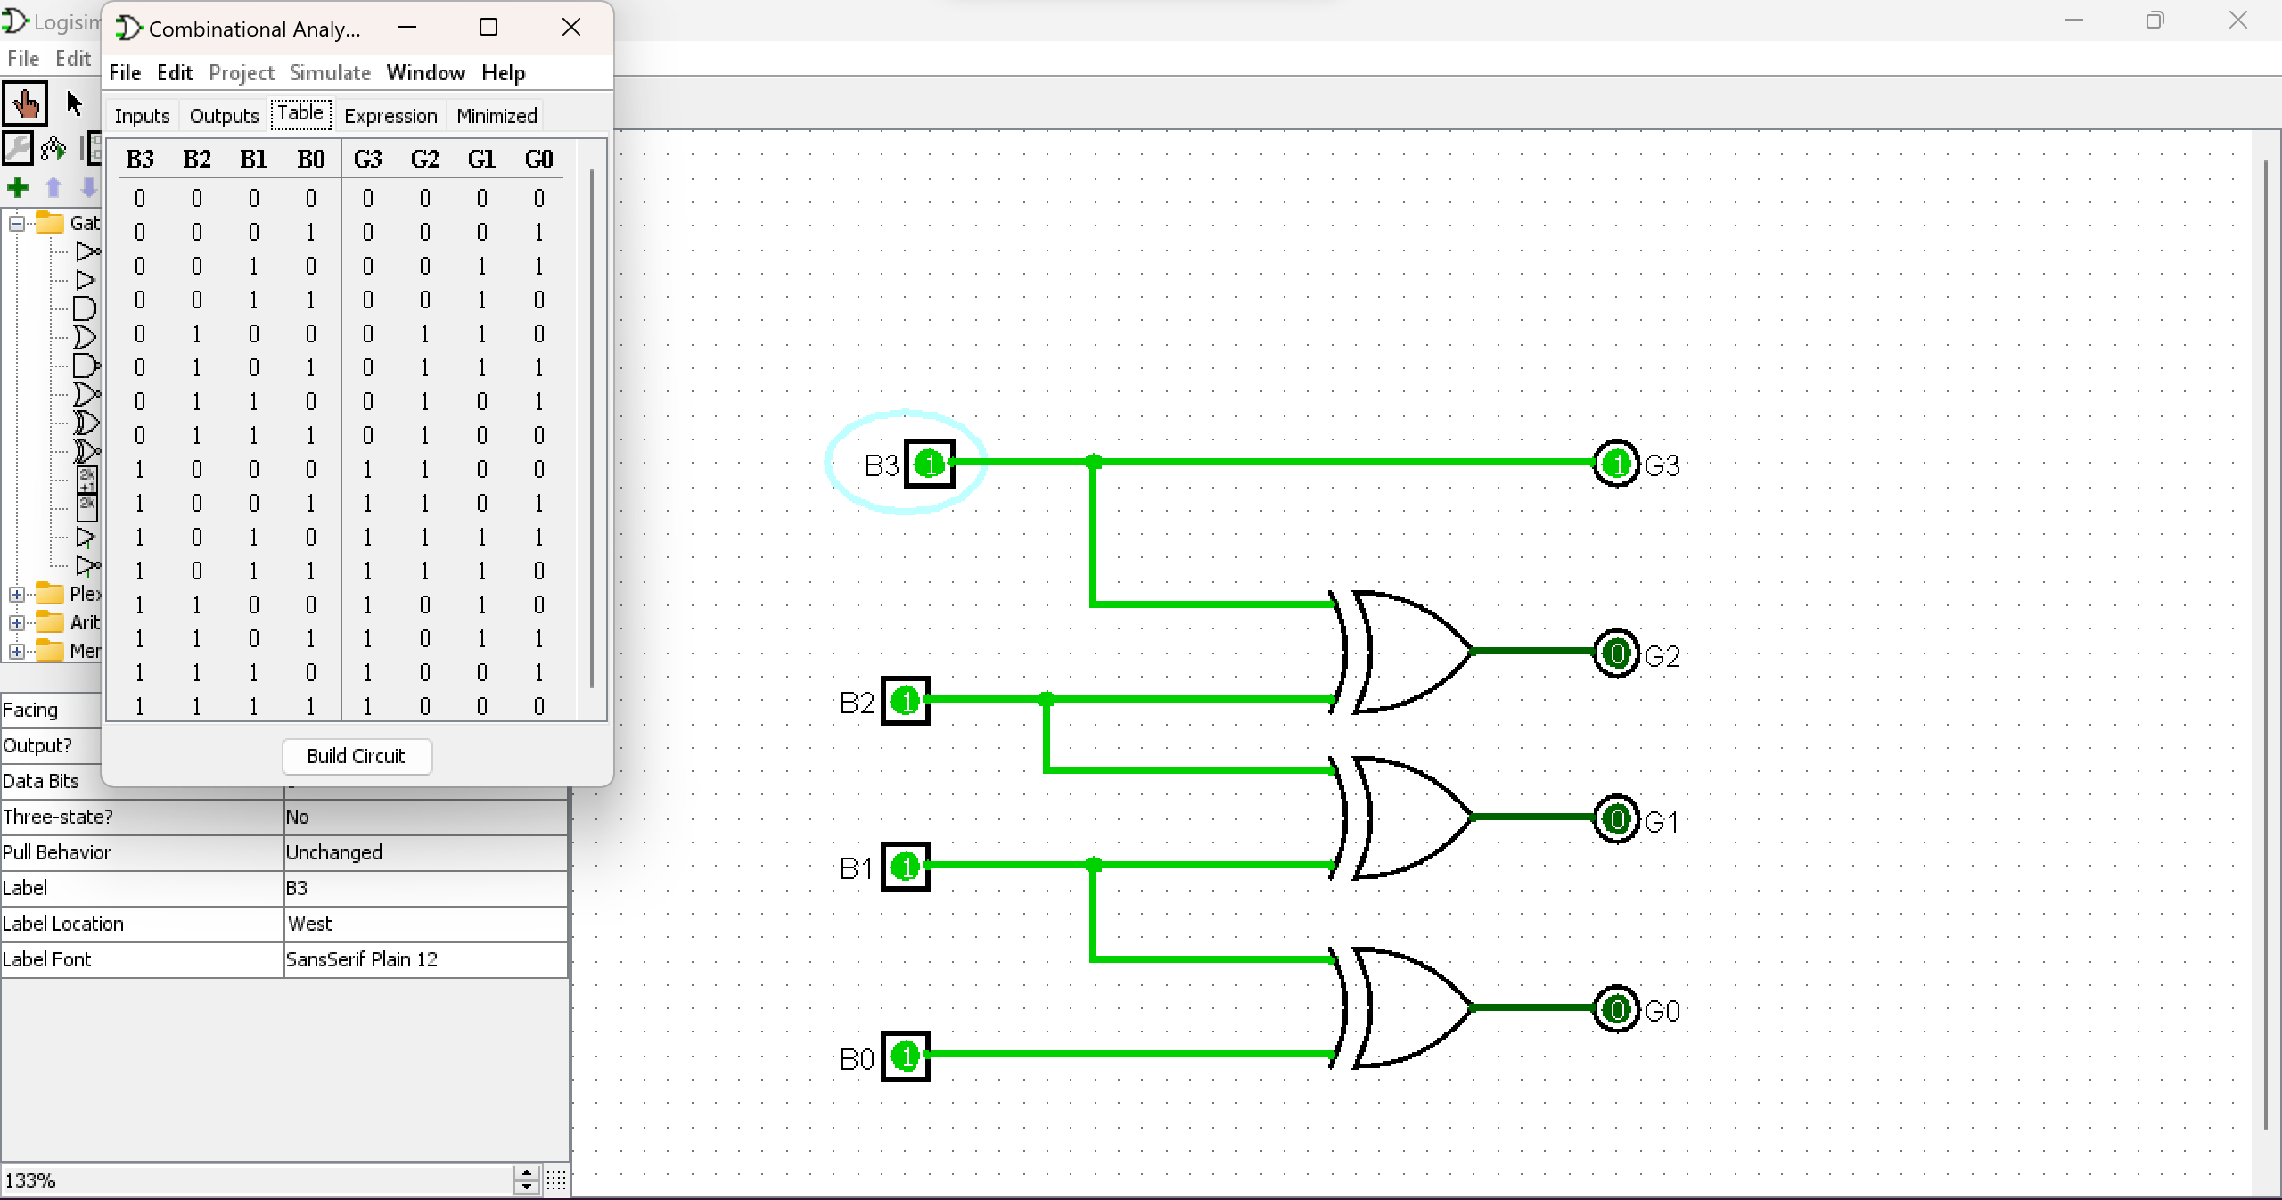

**G3 = B3  
G2 = B3 (+) B2  
G1 = B2 (+ )B1  
G0 = B1 (+) B0**

**Gray to Binary :**

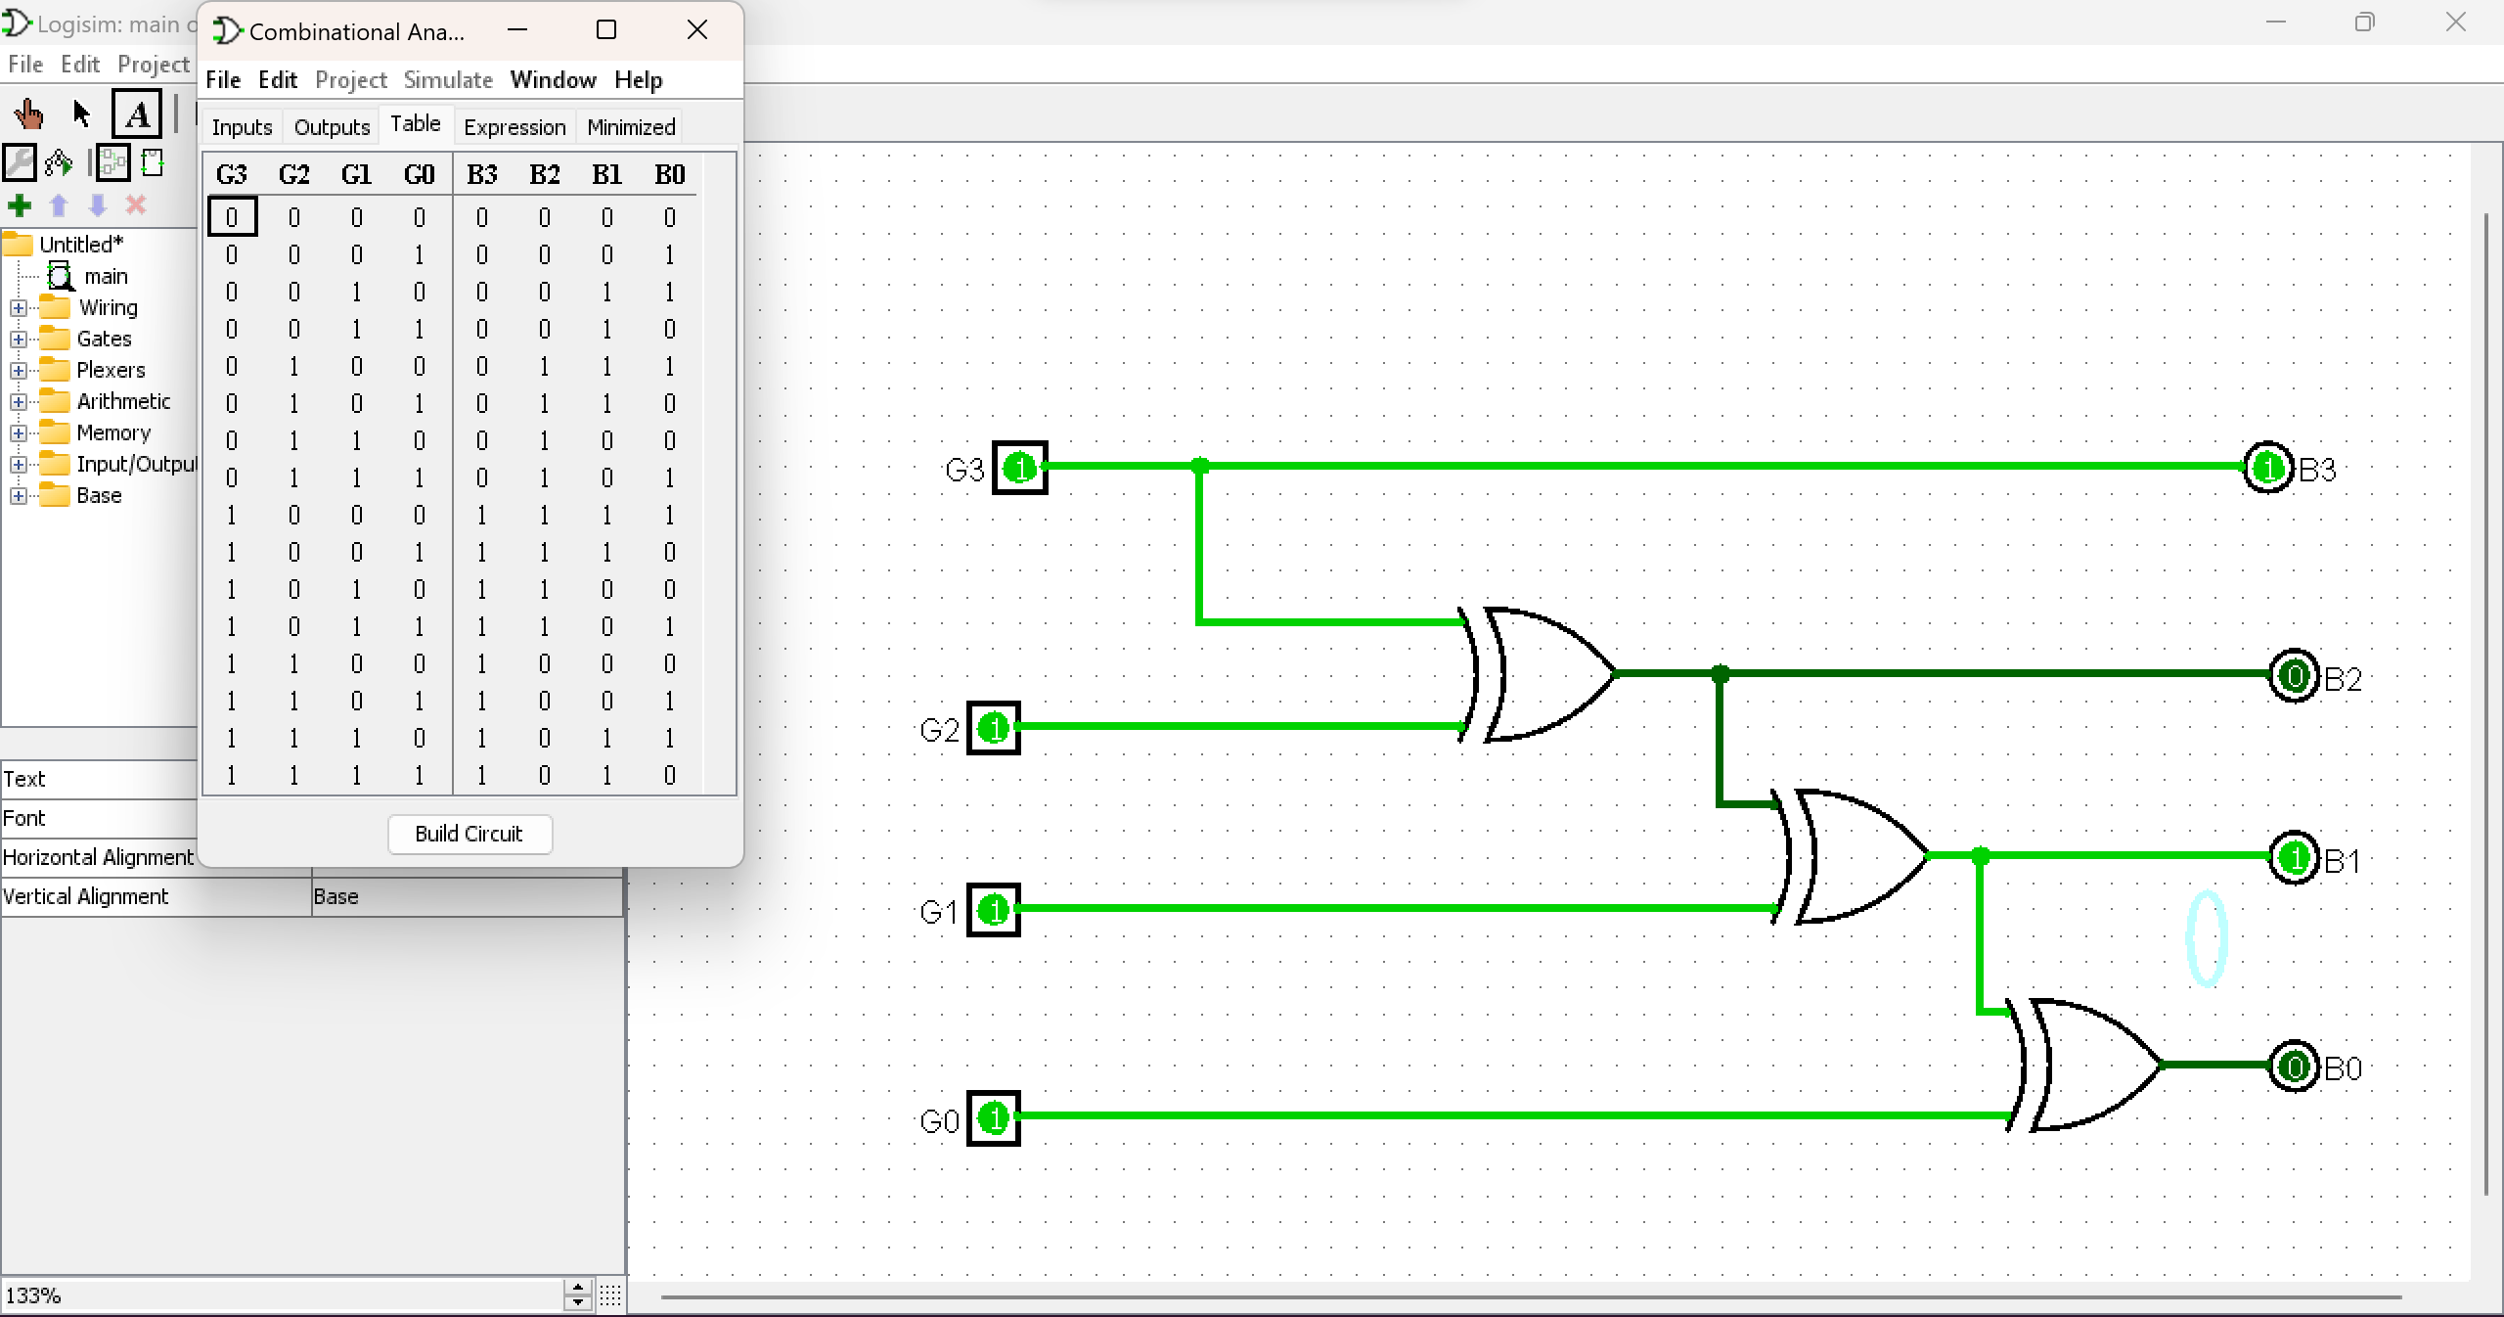

**B3 = G3  
B2 = G3 (+) G2  
B1 = G3 (+) [G2 (+) G1]  
B0 = [G3 (+) (G2 (+) G1)] (+) G0**

**➢ CODE CONVERSION TABLE:**

|  |  |  |  |  |  |  |  |
| --- | --- | --- | --- | --- | --- | --- | --- |
| **BINARY** | | | | **GRAY** | | | |
| **B3** | **B2** | **B1** | **B0** | **G3** | **G2** | **G1** | **G0** |
| **0** | **0** | **0** | **0** | **0** | **0** | **0** | **0** |
| **0** | **0** | **0** | **1** | **0** | **0** | **0** | **1** |
| **0** | **0** | **1** | **0** | **0** | **0** | **1** | **1** |
| **0** | **0** | **1** | **1** | **0** | **0** | **1** | **0** |
| **0** | **1** | **0** | **0** | **0** | **1** | **1** | **0** |
| **0** | **1** | **0** | **1** | **0** | **1** | **1** | **1** |
| **0** | **1** | **1** | **0** | **0** | **1** | **0** | **1** |
| **0** | **1** | **1** | **1** | **0** | **1** | **0** | **0** |
| **1** | **0** | **0** | **0** | **1** | **1** | **0** | **0** |
| **1** | **0** | **0** | **1** | **1** | **1** | **0** | **1** |
| **1** | **0** | **1** | **0** | **1** | **1** | **1** | **1** |
| **1** | **0** | **1** | **1** | **1** | **1** | **1** | **0** |
| **1** | **1** | **0** | **0** | **1** | **0** | **1** | **0** |
| **1** | **1** | **0** | **1** | **1** | **0** | **1** | **1** |
| **1** | **1** | **1** | **0** | **1** | **0** | **0** | **1** |
| **1** | **1** | **1** | **1** | **1** | **0** | **0** | **0** |

**CONCLUSION -** The design and testing of 4-bit Binary to Gray and Gray to Binary Converter circuits using Logisim successfully demonstrated the functionality of these converters. They efficiently converted between binary and Gray code representations, confirming their suitability for integration into digital systems.